**Protonic defects, hydrogen-bond networks and long-range charge transport in phosphorus oxoacid systems**

Linas Vilčiauskas

Vilnius University and the Center for Physical Sciences and Technology (FTMC), Vilnius, Lithuania.

Phosphorus oxoacids such as (H3PO4, H3PO3, and H3PO2) are some of the most interesting proton conducting systems known to science. For example, pure liquid phosphoric acid (H3PO4) has the highest intrinsic proton conductivity of any known substance and is a useful model for understanding proton transport in other phosphate-based systems in biology and clean energy technologies. Aqueous media transport protonic defects through local hydrogen bond rearrangements that drive individual proton transfer reactions. In contrast, strong, polarizable hydrogen bonds in phosphorus oxoacids produce coupled proton motion leading to the formation of extended, polarized hydrogen-bonded chains. The interplay between these chains and a frustrated hydrogen-bond network gives rise to the high proton conductivity. In this talk, I will review some of our contributions and potential future directions in understanding protonic defect formation and transport mechanisms in this and related systems.

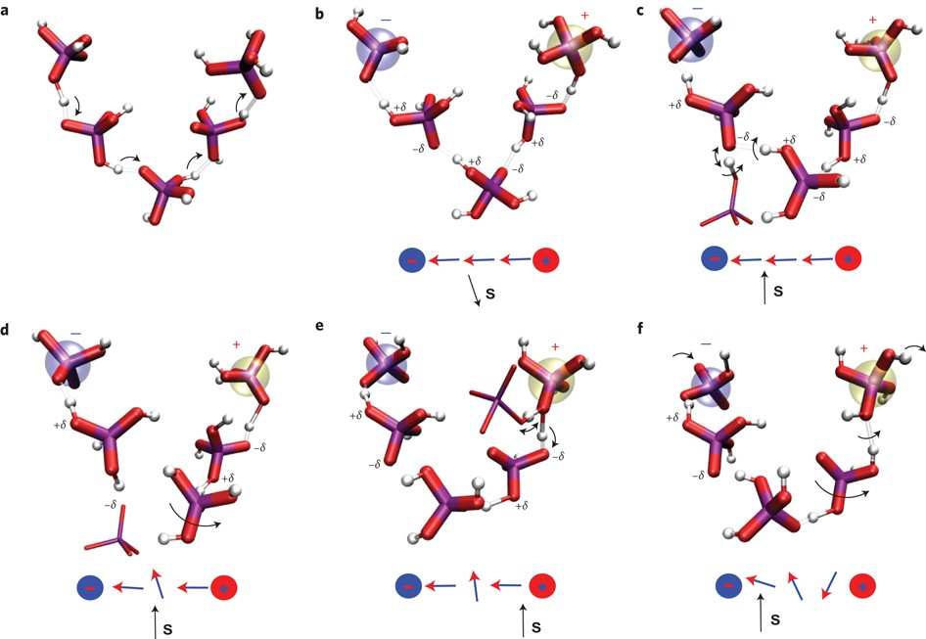

**References:**

[1] Vilčiauskas et al. *Nature Chemistr*y, 4, 461-466 (2012).

[2] Melchior et al. *Phys. Chem. Chem. Phys.*, 19, 587-600 (2017).

[3] Mikalčiūtė et al. *Phys. Chem. Chem. Phys.*, 23, 6213-6224 (2021).

Biography

Linas Vilčiauskas received his B.Sc at Vilnius University and M.Sc. at the University of Ulm. He obtained his Ph.D. from the University of Stuttgart while working with Klaus-Dieter Kreuer and Joachim Maier at the Max Planck Institute for Solid State Research on the proton transport mechanisms in phosphorus oxoacids. After postdoctoral stays at New York University and the University of Texas at Austin, he is currently back in Lithuania as a Professor at the Institute of Chemistry of Vilnius University and the Head of the Electrochemical Energy Storage Group at the Center for Physical Sciences and Technology (FTMC). His current interests mainly focus on the fundamental and applied aspects of electrochemical energy conversion, understanding and applications of aqueous batteries and phosphate framework materials.